**Assignment 2**

Q)Write a java program to accept conventional matrix and convert it into sparse matrix. Implement simple transpose and fast transpose algorithms on sparse matrix.

Input:-

**package** ass_2;

**import** java.util.Scanner;

**public** **class** Main {

**public** **static** **void** main(String[] args) {

Scanner scn = **new** Scanner(System.***in***);

System.***out***.print("Enter the no. of rows : ");

**int** r = scn.nextInt();

System.***out***.print("Enter the no. of columns : ");

**int** c = scn.nextInt();

System.***out***.print("Enter the matrix : \n");

**int** count = 0;

**int**[][] arr = **new** **int**[r][c];

**for** (**int** i = 0; i < r; i++) {

**for** (**int** j = 0; j < c; j++) {

arr[i][j] = scn.nextInt();

**if** (arr[i][j] != 0) {

count++;

}

}

}

System.***out***.println();

**int**[][] sparse = **new** **int**[count + 1][3];

sparse[0][0] = r;

sparse[0][1] = c;

sparse[0][2] = count;

**int** s = 1;

**for** (**int** i = 0; i < r; i++) {

**for** (**int** j = 0; j < c; j++) {

**if** (arr[i][j] != 0) {

sparse[s][0] = i + 1;

sparse[s][1] = j + 1;

sparse[s][2] = arr[i][j];

s++;

}

}

}

System.***out***.println("The sparse matrix is : \n");

**for** (**int** i = 0; i < count + 1; i++) {

**for** (**int** j = 0; j < 3; j++) {

System.***out***.print(sparse[i][j] + " ");

}

System.***out***.println();

}

System.***out***.println();

// normal transpose//

**int**[][] trans = **new** **int**[count + 1][3];

trans[0][0] = r;

trans[0][1] = c;

trans[0][2] = count;

**int** it = 1;

**for** (**int** x = 1; x <= c; x++) {

**for** (**int** i = 1; i < count + 1; i++) {

**if** (sparse[i][1] == x) {

trans[it][0] = sparse[i][1];

trans[it][1] = sparse[i][0];

trans[it][2] = sparse[i][2];

it++;

}

}

}

System.***out***.println("Representation of Transpose Matrix(Normal Transpose)");

**for** (**int** i = 0; i < count + 1; i++) {

**for** (**int** j = 0; j < 3; j++) {

System.***out***.print(trans[i][j] + " ");

}

System.***out***.println();

}

//Fast Transpose

**int** n=0;

**int**[][] fastTranspose= **new** **int**[100][3];

**for**(**int** i=0;i<=2;i++)

{

**for**(**int** j=0;j<c;j++)

{

**if**(sparse[j][1]==i)

{

fastTranspose[n][0]=sparse[j][1];

fastTranspose[n][1]=sparse[j][0];

fastTranspose[n][2]=sparse[j][2];

n++;

}

}

}

System.***out***.println("Representation of Transpose Matrix(Fast Transpose)");

**for**(**int** i=0;i<c;i++){

**for**(**int** j=0;j<3;j++)

{

System.***out***.print(fastTranspose[i][j]+" ");

} System.***out***.println();

}

}

}

OUTPUT:-

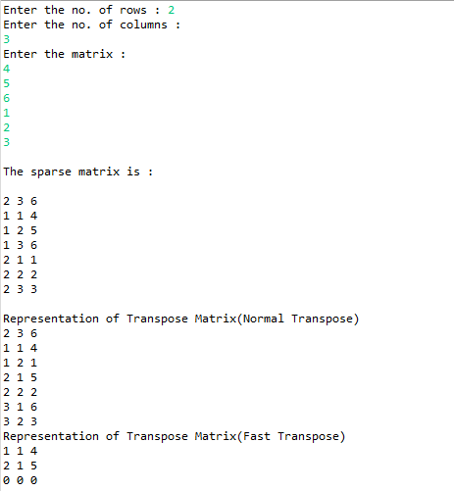

Name:- Yashraj Vijay Aware

PRN no:- 22110167

Roll No.:- 224006

Div:- D

Div.:-D1